**Ranking for the Most Powerful NBA Players in History**

Measure it by your own standards

Yichao Sun  
 Portland State University  
 Portland OR  
 yichao@pdx.edu

**NBA Overview**

The NBA (National Basketball Association) is well known all over the world. Although it is actually a men’s basketball league for American because 29 out of 30 teams are in America. However, the average basketball level in this league is much higher than the world average which likes its name. Even though some powerful basketball players are not born in America. They will still join the NBA for their better career development.

**Ranking for the NBA players are always the controversial topic day to day**

The NBA has many fans over the world. Fans always like to compare with their favourite players and teams, many fans think their favourite player is much better than they look like, is that true? Actually it is really difficult to compare two players who are not far apart, even without personal prejudice. If you try to ask many wise NBA fans: can you rank the most powerful players in history? You will always get the same answers: it is impossible. Also, there are no authoritative sites or institutions that can do such things. Furthermore, even the NBA never posts an official ranking. To sum up, to precisely rank the NBA players in history is impossible! Because everyone has a different standard of evaluation and we cannot use “Ture” or “False” to judge their evaluation.

**What is the most common factor that evaluates an NBA player?**

In the most common way, these following things will be counted for a single NBA player’s achievements:

1 Amount of final championships: no matter what the process, the final aim for a NBA player is to obtain the final championship. It is the supreme honor in the NBA.

2 Aggregated personal Data: for example Kareem Abdul-Jabbar got 38387 points totally in his NBA career. Dennis Rodman got 11954 rebounds. Base on data from ESPN, point, rebounds, assist, steals, blocks are 5 kinds of data to evaluate the positive performance of a NBA player

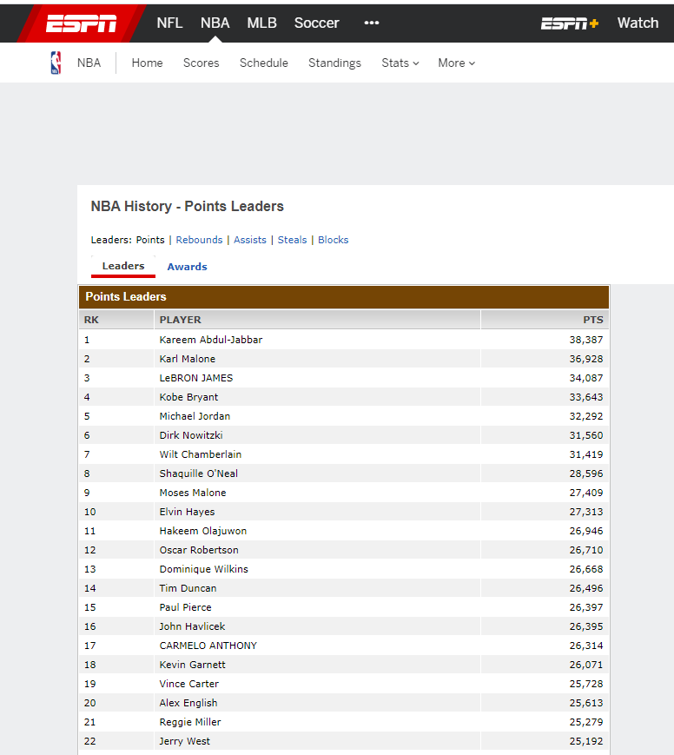3 Averaging personal data: which means the average data the player gets per game in his life. Compared to Aggregated personal data, averaging personal data is more important. To calculate it, let total points, rebounds, assist, steals, blocks in one’s career divide by his total game played.

4 Amount of MVP’s and FMVP’s: Both two awards are remarkable annually. The result comes from some prestigious NBA experts voting. However, they will never publish the reason why they voted who they voted for. The result is that they came up with mankind’s thinking instead of truly data science. Some of the experts may reference NBA players’ personal data for this reason, furthermore, they must consider other factors such as: is this player can make his team and team better? In general, this is also important, but it cannot be evaluated by data because it is a pretty abstract factor, we will never know whether these experts make their voting reasonable, we never know.

5 The number of ALL-Star selections: This was voted for online by NBA fans over the USA. If a player can be an ALL-Star player in this season, which means he already has a remarkables strength, so that he can get many fans. Despite his individual strength, charisma is also a decisive factor in the outcome of this election. Charisma should not be used as a measure of a player's ability.



**However, Many cases can prove that we cannot establish a strict standard**

To completely understand the following statement is based on you being an NBA fan. It is impossible to measure with the most accurate data for these examples:

Problem 1: Bill Russell got 9 final championships while he was a NBA player, and Micheal Jordan got 6 final championships. However, during Bill Russell got his 9 championships, there were only 8-12 NBA teams that time, but when Micheal Jordan got his championship there were more than 27 - 28 teams in the NBA, so do you think Jordan is definitely inferior than Bill?

Problem 2: Rob Horry is a role player that Michaeal Jordan is much better than him in almost everyone’s opinion, but Horry got 1 more final championship than Jordan. Will it cause a problem if you evaluate them based on the amount of championships as well?

Problem 3: Some say that Tracy McGrady was better than Kobe at his career peak. However, Tracy’s career was only 1-2 seasons, but Kobe’s career peak is much longer than McGrady. All NBA admits that Kobe had a 10 years period of dominance. How do you rank them?

Problem 4: Penny Haraway was a player who had the potential to surpass Jordan in most people's opinion during 1995, but injuries totally hurt his career, how do you evaluate his power?

Problem 5: Wilt Chamberlain has exaggerated personal data in his whole NBA career which is much better than Bill Russell’s personal data. However, Bill took 9 championships away from Wilt. What do you think about it? Which one is the most important thing? personal data or final championships?

Problem 6: Lebron James got second places 6 times in different seasons. If you estimate a NBA player based on his amounts of final championships. Which means James is no different with the players in the last places for that season?

Problem 7: In season 2017-2018, almost every person certainly considered James the most powerful active player at that time but he didn't have any good teammates. Oppositely, Golden State Warriors have 4 all-star players and they got the championship. Is James really inferior to any of them in Golden State Warriors?

Problem 8: MVP was established in 1957, and FMVP was established in 1969, however, the NBA match was started in 1947. The players active between 1947 - 1969 can never have an MVP award, as well as MVP for players active between 1947-1957. It is unreasonable to campare the number of MVP and FMVP awards for all players in history.

**It’s Hard to do, but it’s not impossible to do**

Just as human beings are constantly exploring the secrets of the universe, although it is difficult for us to know the truth of the formation of the universe, we are constantly making new discoveries in our learning and exploration. We can establish algorithms to solve some of the problems even if it seems hard to do. For example, for problem 1, we can establish a new data to represents the achievement value that the number of championships brings to the player, the roughly formula is (number of NBA teams at that time * number of final championships = achievement value. Bill won 9 NBA championships with 8 teams, the achievement value is 8 * 9 = 72; Jordan won 6 NBA championships with 28 teams, the achievement value is 6 * 28 = 168; For the result, Jordan got a higher achievement than Bill. Is that more reasonable? Furthermore, for problem 2, we should take care of both the number of final championships and 2 kinds of personal data, you know, even though Horry has 1 more championship than Jordan, his aggregated personal data and averaging personal data is very far away behind Jordan’s. It is just like final grade for a course, student A got 80% for his homework but 100% for his final group project, however, student B got 100% for his homework and 99% for his final group project, so who will get a better grade? I know the weight of the final group project and homework is a big case, for sure what I'm going to do is collect remarkable achievements and data for NBA players and use a formula I created to rank these famous NBA players. I will talk about the weight problem later.

**Which factors do we really need to count?**

My work here is just like establishing a grade policy for a course, should my course include a graded project, should my course include a graded video assignment? How much weight for the final exam? How much weight for each homework? Let’s ignore the mixed proportion of weight. Firstly, I should figure out what kinds of graded sections I should add to the course. So what factors should I count to evaluate the power of a NBA player?

**East championship, West championship, Final championship and whether the player’s team had qualification for the playoff that year**

Although there is only one final championship every year, however, you cannot deny that the remaining 29 teams have different levels of power. Whether the team had the qualification for the playoff is a good standard to distinguish the good team and bad team. Also, the NBA establishes the award of east championship, and west championship, which should be another factor to care about. The championship team may have a final championship and either east or west championship in a single year. Specifically, I'm going to use the formula: (playoffs times - East/west championships *15/8 + (east/west championships - final championships) *15 + championships *30, “* 30” which means you team is the best one out of 30, “* 15” as well, also if a team got a final championship in a single season, it must be the east/west championship for that year and have qualification for playoff that year, so east/west championship and playoff for that season will not be counted. In the early NBA, only the champion and the second place were counted

**The Player Efficiency Rating**

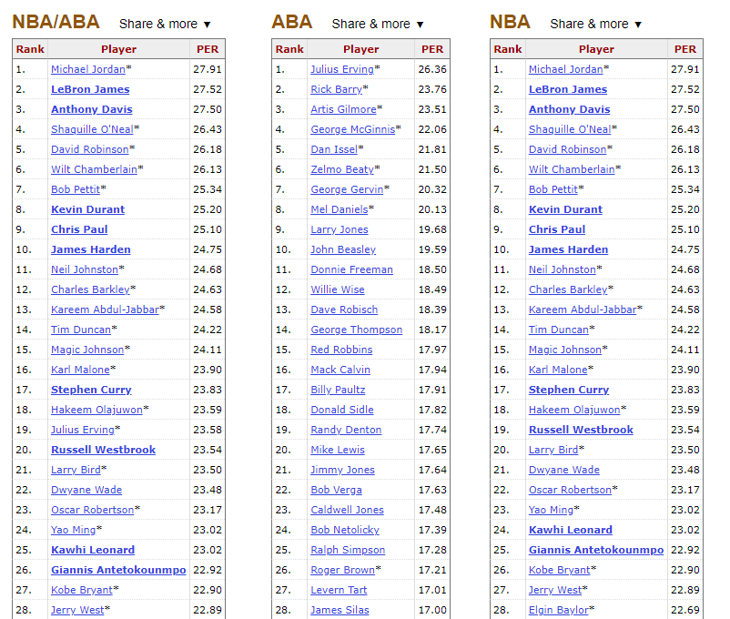

There is a reason why almost every authority or website thinks Michael Jordan is the best NBA player. The Player efficiency rating is the most reasonable way to evaluate a player’s performance on the court throughout his career, which is more reasonable than averaging personal data. Why? Player efficiency rating is developed by ESPN.com columnist Jon Hollinger. In John’s words, In John's words, "The PER sums up all a player's positive accomplishments, subtracts the negative accomplishments, and returns a per-minute rating of a player's performance." In other words, unlike averaging personal data, PER counts the negative performance for a player as well. Imagine that, if a player got 20 points in one game, but because of the reason for his mistakes during the game, the rival got 30 points, do you consider him as a hero? Although there are still some people who object to this evaluation criterion, it is the most reasonable evaluation of a player's efficiency at present.

**Defensive Player of the Year award**

Offense and defense are theoretically the same in basketball.Unlike on the offensive end, a player's performance on the defensive end is difficult to assess.Apart from blocking shots and steals, the One-year Award is the only piece of data at the moment that can be used to evaluate a Player's Defensive performance.The only downside to PER is that it ignores players on the defensive end, which would give a more realistic assessment

**Aggregated personal Data**

This is the factor that we still need to consider. Imagine that you are a employer and you want to hire someone to working for you, if interviewee A said I can earn 1000 dollars for you per day but I can only working for you one months, however, the interviewee B said I can only earn 900 dollars for you per day but I can working for you forever, who will you choose? Even efficiency is really important, endurance should also be a regradless fact. It is also very important for a player to bring long-term and stable value to a team, because the team will pay a certain price and time to restructure the team due to the core leaving, which will have a negative impact on the team's record.

**MVP and FMVP**

“There is something to be said for being named the most valuable player. In determining a player’s greatness, often MVP awards are the most legitimate and withstanding measures of comparisons. Being the most valuable player of a year means that, for an entire season, you were the best of the best. This is pivotal in comparisons.” written by E lijah in his article: NBA MVP vs. Finals MVP: determining an NBA player’s greatness. In Elijah's view, an MVP means you are the best player of the season, while an FMVP means you are the best player of the season on the best team. The winners are often not the same person during the season.Both are important, and the concept of the best individual player is easy to understand, but what does it mean to have the best player on the best team?Phil Jackson once said to Jordan, "The best players make all the players around them better." Basketball is a five-player team sport, and winning often depends on teamwork.In NBA championship cases, very few teams win on the strength of an individual member of the team. MVP and FMVP represent a player whose individual and team abilities are at the top.

**Other things have already covered by former section**

As mentioned earlier, the All-Star game is a recreational game, and eligibility depends on a star's popularity, which cannot be considered as a practical factor. Furthermore , the scoring title had already covered by aggregated personal data and PER, these things should be be counted

**The Formula for output the final result**

As i said before, everyone has their own standards in mind. For this reason, I will let users customize a formula to calculate the final ranking result. The result is the addition of basic point and extra point, basic point includes aggregated personal data and PER. Users can define the weight of both kinds of data such as let PER be the 70% for the basic points, and aggregate personal data will be 30%. After that, Based on the criteria of 100 points for the player with the highest basic points, you will customize the number of points for the second place and then use this rule to determine the final Basic points for all the other players. Extra points including MVP, FMVP, All kinds of championships, playoff times, and defensive player award. It's not a percentage because some really good players have never won a championship and you can't just give them zero points.Weight for each item is also user-defined. Furthermore, I will also establish a default formula that it’s result will agree on one of the most prestigious ranking “updating and ranking the 50 greatest NBA players of all time” by Omar Guerrero.

**Focus on data science**

Our course is data science, and my work here is also data science. The standard of ranking should be only based on the elements I figured out before, no other abstract factor or other special factor. For example, Wilt Chamberlain has high personal Numbers, but he is deliberately raising his personal Numbers at the expense of the team.That led to him being great, but his teams rarely had good records. He is not a good basketball player in some way. However, that’s not our data science. We only use data science to get the final result even if I have my own standard in my mind.

**REFERENCES**

[1] NBA History - Rebounds/Points/Assists/Steals/Blocks Leaders ESPN <http://www.espn.com/nba/history/leaders/_/stat/rebounds>

[2] calculating PER - Basketball reference

https://www.basketball-reference.com/about/per.html

[3] Player Efficiency Rating (PER): Simple Things To Know By CoachSicko On October 21, 2018

https://www.hoopcoach.org/player-efficiency-rating-per-simple-things-to-know/

[4] NBA MVP vs. Finals MVP: determining an NBA player’s greatness written by elijah

<http://www.basesandbaskets.com/2013/06/nba-mvp-vs-finals-mvp.html>

[5] Updating and Ranking The 50 Greatest NBA Players of all time by Omar GuerreroJune 18, 2020

<https://clutchpoints.com/updating-ranking-the-50-greatest-players-nba/>